**Guided Capstone Project Report**

**Executive Summary**

This project analyzed U.S. ski-resort data to guide Big Mountain Resort’s pricing and operational decisions. With the datasets cleaned and patterns explored we were able to estimate optimal ticket prices due to it. Our findings indicated that pricing is strongly related to factors such as skiable acreage, vertical drop and number of lifts which are all expandable and investible things that the park can upgrade when the need calls. In order to attain this, strategic price adjustments and targeted improvements to facilities that align with how these operate.

**Data Wrangling and Preparation**

We began with the national ski resort dataset and verified that Big Mountain Resort was present. After handling missing values and standardizing state/region fields, we removed columns with nulls that were the majority of that column and dropped duplicate rows. Categorical features such as region and state were encoded for later modeling.

**Exploratory Data Analysis**

* Ticket Price Patterns: Western resorts generally charge higher prices, correlating with larger skiable areas and greater vertical drop.
* State-Level Insights: Montana’s average adult weekend ticket price was below the national mean, suggesting room for upward adjustment if quality and amenities justify it
* Feature Relationships: Positive relationships emerged between ticket price and skiable acres, lifts, and annual snowfall. 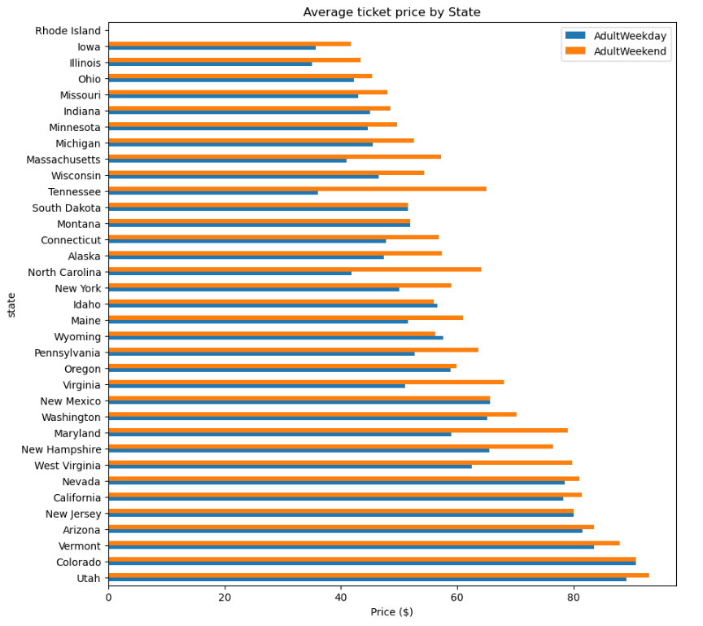

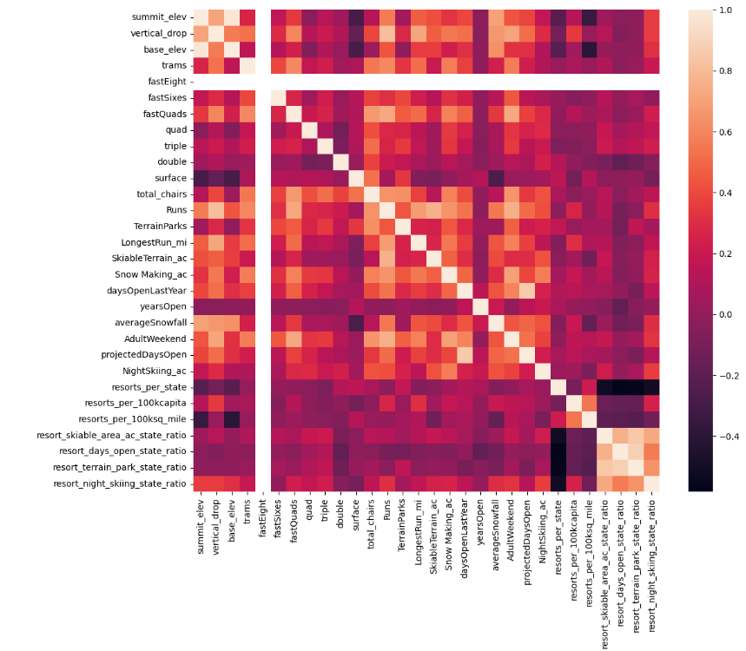

**Modeling and Results**

We first evaluated a simple baseline model using the average price across all resorts, which yields an R² near 0. Next we trained a linear regression model using features such as skiable acreage, vertical drops, number of lifts and snowfall. This improved R² reduced mean absolute error, demonstrating that these attributes meaningfully ticket price variance.

**Recommendations for Big Mountain Resort**

1. Price Optimization:
   1. Slowly increase the price of tickets as it is currently below predicted range based of the resort’s attributes.
2. Infrastructure Investments:
   1. Expanding skiable terrain and adding lifts would likely enable more price increases

**Next Steps**

Deploying the predictive model as a decision-support tool for ongoing pricing strategies while also conducting A/B tests on small seasonal price changes to validate how the demand for it might be needed. In addition, being able to collect more visitor data and pricing data such as merch might influence this decision for the better.